MINING
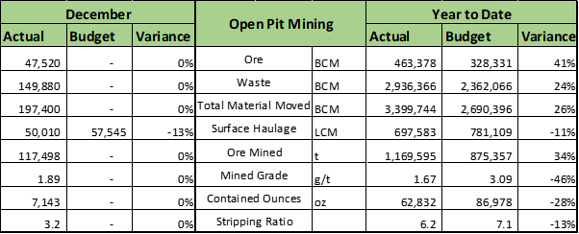
Production

- Mining operations were carried out in Bokrobo and Aliva Central pits with three excavators. Two excavators in Bokrobo pit and one excavator in Aliva Central pit. Mining commenced in Aliva Central Pit on the 18th of December, 2019.

- Total volume of material mined; 197.4k bcm and 33% below forecast with a strip ratio of 3.2:1 against a forecast strip ratio of 3.4:1 for the month. Ore tonnes mined was 117.5k, 29% below forecast @ 1.89 g/t (above the forecast grade of 1.53 g/t) with an open pit contained ounces of 7.1k oz., 12% below forecast. 69.65hrs (2.90 days) lost due to downtimes, 139.83 hrs (5.83 days) lost due to no mineable material. 81.17 hrs (3.38 days) was used in GSA and trimming batters and loading rehandling trucks. 21 hrs (0.88 days) was lost due to restricted ramps access, 22.50 hr (0.94 days) was lost to lack of dumping space due to stockpile being full.

Drill & Blast

- 154.4k bcm of material were blasted within the month from Bokrobo pit, 22.8% below the forecast. Two (2) air blasts exceedances were recorded at Bokrobo pit within the month, no ground vibration exceedance recorded. Shortfall in blasted stock was due to 152.6 hrs (6.35days) lost due to inaccessible drilling floor as a result of restricted pit access. Dewatering

- Dewatering activities were undertaken in Bokrobo pit. Adamus pit is on hold for dewatering activities. Currently there are challenges with dewatering. There is only on working pump on site at the moment. Any downtime on the pump will result in flooding of the pit floor. Stockpile

- Ended the month with a stockpile of 731.4k t @ 0.98 g/t (22.9k oz.). 22% below budgeted ounces and 6% below forecast due to mining behind budgeted areas. Mining Contractors

- Contractor performances in the pits were satisfactory. Surface Haulage

- Volumes re-handled was 50.01k LCM, 13% below budget and 25 % below forecast. There was breakdown of the rehandling trucks and BCM dump trucks had to assist in when the stockpile were full and there was no dumping space on the stockpile. There was acquisition of tipper trucks at the later end of the month. The acquired tipper trucks started working on 20th December, 2019.
FINANCE
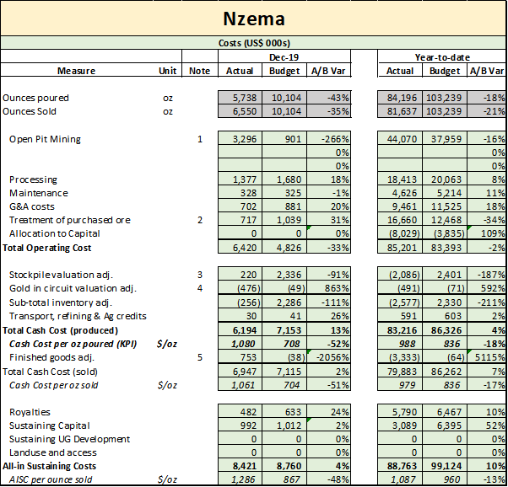
Cost
● Extension of mining at the only active pit resulted in higher mining costs and budget. Bokrobo pit was planned to have been mined out by October 2019.
●Purchase toll ounces 43% below budget at 478oz. (Budget: 833oz)
●A decrease in stockpile balance from previous month resulted in the US$220k charge to profit and loss
●GIC balance for December increase by 440oz over the November balance of 861oz.
●Finished gold balance reduced from the 5,053oz in November to 4,237oz in December resulting in cost charge to profit and loss.
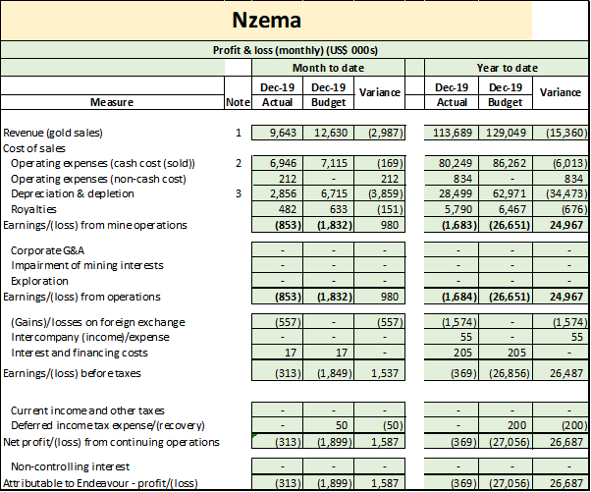
Notes to the Profit & loss
● | MTD:Unfavourable revenue is attributable to lower gold ounces sold (Actual: 6,550oz; Budget: 10,104oz) resulting in a negative volume variance of US$4.4M. YTD: Unfavourable revenue due to negative volume variance of US$27M (21,602oz below budgeted 103,239oz)
● | MTD: Lower processing, maintenance, G&A costs as well as higher GIC balance at month end, taking some costs off profit and loss. YTD: Variance due to increases in stockpile and finished gold balances, thus putting some costs on the balance sheet.
● | MTD/YTD: Lower ounces mined and processed than budgeted resulting in an extension in mine life and lower depreciation charges.

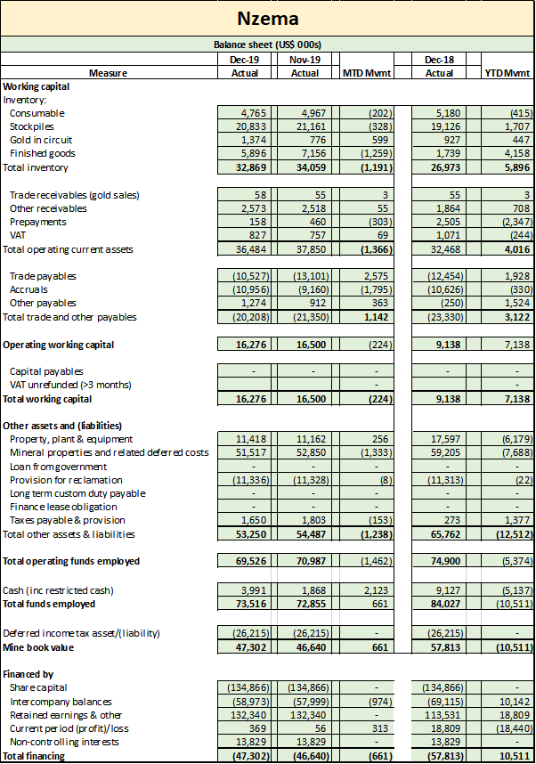
SECURITY
MINING...
Production

- Mining operations were carried out in Bokrobo and Aliva Central pits with three excavators. Two excavators in Bokrobo pit and one excavator in Aliva Central pit. Mining commenced in Aliva Central Pit on the 18th of December, 2019.

- Total volume of material mined; 197.4k bcm and 33% below forecast with a strip ratio of 3.2:1 against a forecast strip ratio of 3.4:1 for the month. Ore tonnes mined was 117.5k, 29% below forecast @ 1.89 g/t (above the forecast grade of 1.53 g/t) with an open pit contained ounces of 7.1k oz., 12% below forecast. 69.65hrs (2.90 days) lost due to downtimes, 139.83 hrs (5.83 days) lost due to no mineable material. 81.17 hrs (3.38 days) was used in GSA and trimming batters and loading rehandling trucks. 21 hrs (0.88 days) was lost due to restricted ramps access, 22.50 hr (0.94 days) was lost to lack of dumping space due to stockpile being full.

Drill & Blast

- 154.4k bcm of material were blasted within the month from Bokrobo pit, 22.8% below the forecast. Two (2) air blasts exceedances were recorded at Bokrobo pit within the month, no ground vibration exceedance recorded. Shortfall in blasted stock was due to 152.6 hrs (6.35days) lost due to inaccessible drilling floor as a result of restricted pit access. Dewatering

- Dewatering activities were undertaken in Bokrobo pit. Adamus pit is on hold for dewatering activities. Currently there are challenges with dewatering. There is only on working pump on site at the moment. Any downtime on the pump will result in flooding of the pit floor. Stockpile

- Ended the month with a stockpile of 731.4k t @ 0.98 g/t (22.9k oz.). 22% below budgeted ounces and 6% below forecast due to mining behind budgeted areas. Mining Contractors

- Contractor performances in the pits were satisfactory. Surface Haulage

- Volumes re-handled was 50.01k LCM, 13% below budget and 25 % below forecast. There was breakdown of the rehandling trucks and BCM dump trucks had to assist in when the stockpile were full and there was no dumping space on the stockpile. There was acquisition of tipper trucks at the later end of the month. The acquired tipper trucks started working on 20th December, 2019.

